Case Study

By
Brittany Hanson

Child Description

AG is a female first grade student at a Title One school in an urban school district. She is seven years old. AG has a baby brother and they live with their mother and father. AG speaks both Spanish and English and her family is Hispanic. AG likes to go to school, read, eat popcorn, and pizza. Her favorite pizza is pepperoni pizza. During my first interview with AG, she seemed outgoing and eager to work with me and learn more things.
The practicum teacher suggested I choose AG for my case study because she is behind in reading and reading comprehension. I noticed while going over sight words with her that she has trouble with words that begin with s. For the s sound she combines sh. She came to the word (sit) and applied the (sh) sound for the s sound. Last semester AG made progress working one on one with another practicum student. The teacher feels that with more one on one teaching, this student can continue to improve and hopefully catch up with her grade level.

Survey Results

The purpose of our survey was to find out the reading habits and resources of our students. We asked our students four questions: 1.) Do you like to read? ; 2.) Do you read at home? ; 3.) Do you read alone or with a family member? ; 4.) Where do you get you books besides school? We administered the survey using the Elmo in the classroom. My partner, Tashia, read the questions aloud and I circulated the classroom to help any individual student who had questions or problems answering. The survey only required students to circle an appropriate response.
I took the results from the surveys and calculated percentages. I created both bar graphs and pie charts to represent our survey findings. I then took the answers from the student in my case study and reflected on how she compared to the rest of the students in the classroom. The results are as follows: My case study student (AG) scored within the 69% of the class who answered the question “Do you like to read?” with a yes. 19% of the class answered sometime to that questions and 12% answered never. When asked the question “Do you read at home?”, 44% of the sixteen students said yes, 25% said sometimes and 31% answered never. AG was in the 25% of the class that answered sometimes. When the sixteen students in this first grade classroom were asked if they read alone or with a family member, they were equally divided. 50% read alone and 50% read with a family. My case study student answered that she read alone. The last question we asked the students was “Where do you get books besides school?” We gave them four answers to choose from. 31% answered public library, 13% said church, 50% said family member and 6% said they did not get books outside of school. AG answered that she got her books outside of school from the public library.

Samples of Writing

Writing Analysis

Name: AG

Grade Level: 1st Grade

Reviewer: Brittany Hanson

Writing Sample:

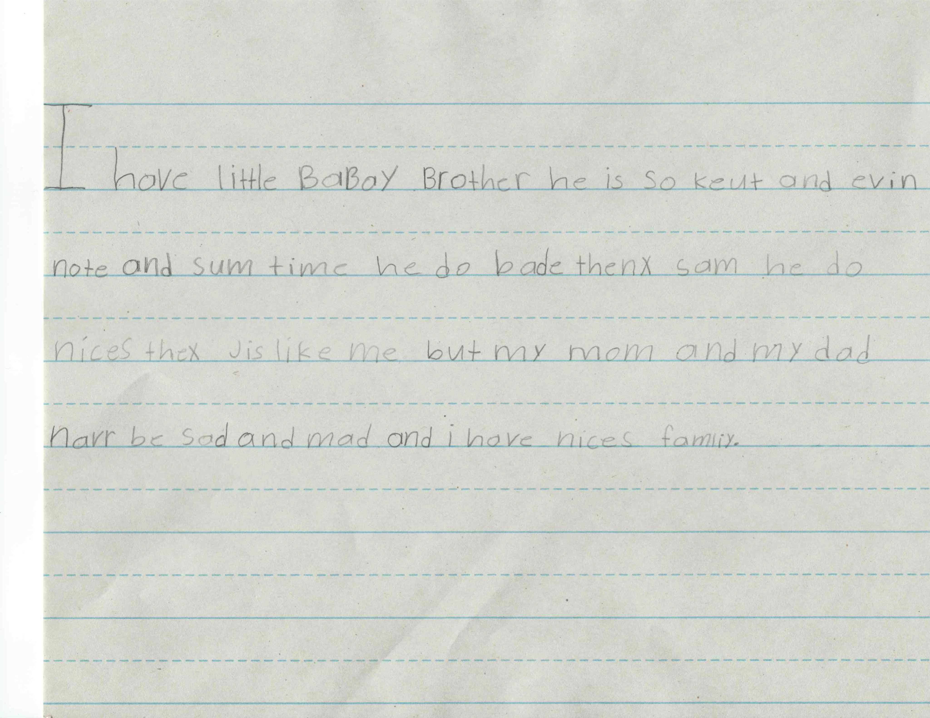

Translation: I have little baby brother he is so cute and even naughty and sometime he do bad thing some he do nice thing just like me but my mom and my dad never be sad and mad and I have nice family.

For this piece of writing my case study student (AG) was prompted by me to write a story about any subject she desired. She wanted to write about her family. In the six traits of writing there are 6 stages. These stages are ideas, organization, voice, word choice, sentence fluency, and conventions. AG had no trouble coming up with the idea for her story. She tends to do most of her creative writing about her family—especially her baby brother. The story was short but understandable. She introduced her baby brother right away, so the topic was clear. The story lacks much substance and tends to list things such as “my baby brother is cute….naughty…sometimes does bad things,…..sometimes does nice things.” However, AG’s voice does come through because you can tell she is sincere about her subject and loves her family.
The organization of this writing example has problems. AG just used on run-on sentence to write the story. The story has a beginning in that she tells she has a baby brother. It has a middle that tells he is cute, naughty, sometimes bad and sometimes good. She has a conclusion that her parents don’t get mad and she has a nice family. There are many grammatical errors and confusing sentence structure.
AG is sounding out and spelling her words fairly well. She spelled such words as little, brother, mad, sad, and family correctly which is good for her first grade level. She misspelled others such as “bade” for bad (CVCe) and “navr” for never.
When I work with AG I will work on her sight words, sentence structure, and punctuation. I also noticed in this writing that AG didn’t capitalize the “I” in the middle of her writing. So I will work with her on capitalization.

Samples of Spelling

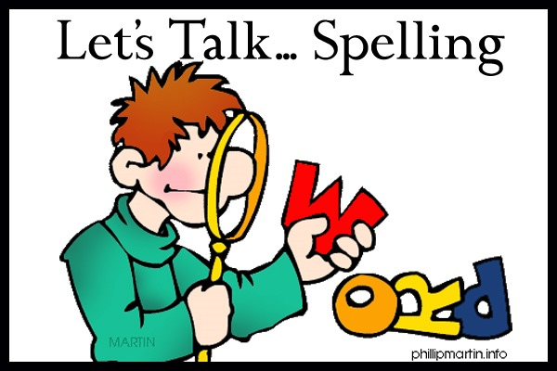

SPELLING ANALYSIS
Name: AG
Grade level: 1st Grade
Reviewer: Brittany Hanson

Writing Sample:

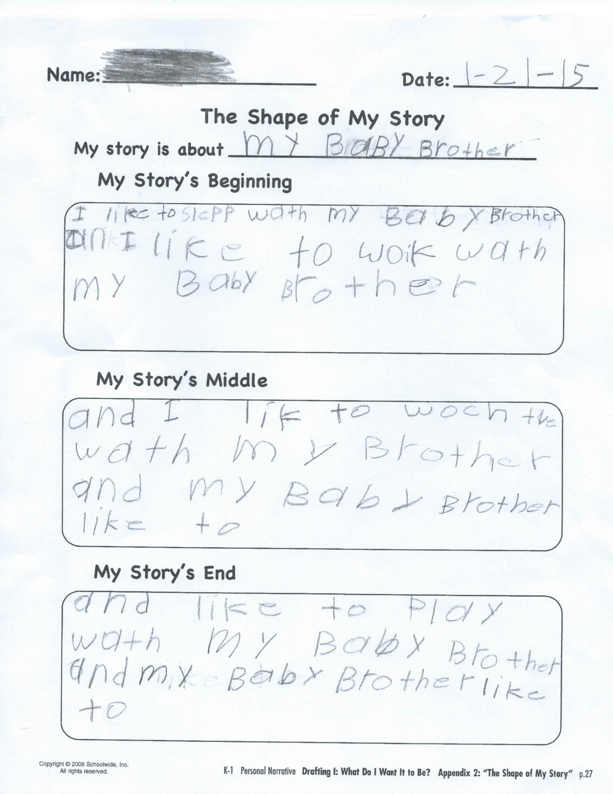

Translation: My Baby Brother
I like to sleep with my baby brother and I like to walk with my baby brother and I like to watch TV with my brother and my baby brother like to and like to play with my baby brother and my baby brother like to

Spelling Analysis Chart:

Emergent | Letter Name-Alphabetic | Within-Word Patterns | Syllables  and Affixes | Derivational Relations
 | Wath (with)  Woik (walk)  Lik (like)  Woch (watch)  Tve (T.V.)  An (and) | Slepp (sleep)

Conclusion: The students spelled 78% of the words correctly. Most of her spelling errors were in the letter name-alphabetic and within-word patterns stages, which is typical of first graders’ spelling.

Topics for Instruction: Sight words, CVCe vowel pattern, making a sentence, punctuation

In the example piece of writing from my case study student, I feel AG falls in the stage 2 of the spelling development chart. Stage 2 is the letter name-alphabetic section. In this stage, children learn to represent phonemes in words with letters. Students at this level are able to demonstrate the concepts of: the alphabetic principle; consonant sounds; short vowel sounds; consonant blends and; digraphs. My case study student understands the alphabet and most of its sounds. She also spells the beginning and ending sounds of words correctly. An example of this would be spelling sleep as “slepp” and with as “wath.” When AG is writing words, she sounds out the words and spells what she hears. AG is having trouble with CVCe vowel patterns. An example of this is writing like as “lik.”
In this writing sample it is obvious that my case study student is not understanding sentence structure and using punctuation. The writing of this story was blocked off on the paper to show students a story has a beginning, middle, and end. AG wrote her story as one continuous sentence with no punctuation. Sentence fluency is a problem because some fragments don’t make sense and are repetitive.
Suggestions for helping AG through this stage of spelling development into the next stages could include: working on sight words, CVCe vowel patterns, making a sentence, and using punctuation.

IRI
(Informal Reading Inventory)

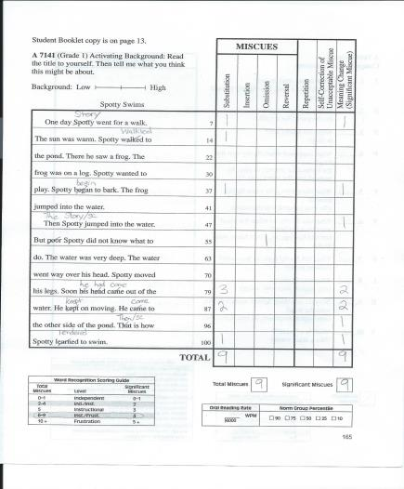

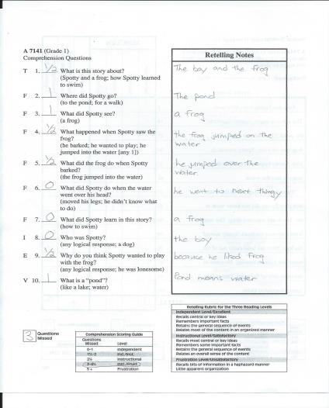

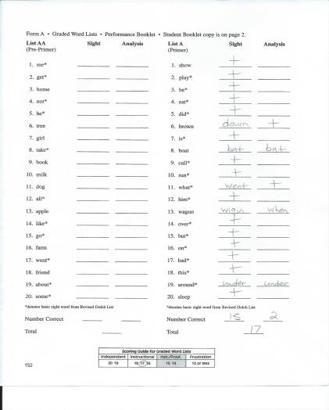

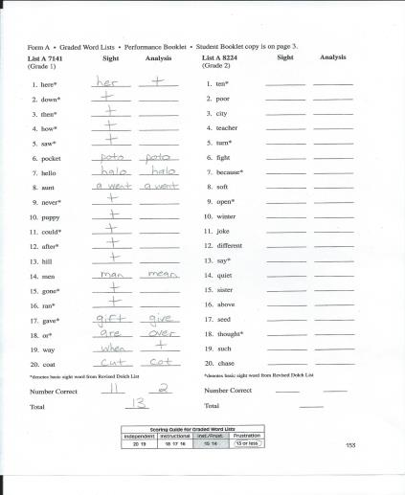

An IRI (Individual Reading Inventory) is an individually administered formal reading test. It is composed of a series of graded word lists and graded passages. This inventory helps teachers gain insights into students’ reading behavior. A teacher can find out the student’s independent reading level, instructional level, frustration level, strategies for word identification, fluency, strengths and weaknesses in comprehension, and listening level. The results will help support the daily instructional decisions that teachers need to make. For the comprehension part there are five different questions that follow the graded reading passage. These questions are over: topic, fact, inference, evaluation, and vocabulary.
I conducted the IRI with my case study student on March 25, 2015. I began by giving my case study student the graded word lists first. The list I used for this was list A (primer). This is the level just below the first grade skill ability. AG scored a 17 on this list which shows she is at the instructional level for her sight words. I then proceeded to give AG list A 7141 which tests at first grade level. She scored a 13 on this list. This shows that she is at the frustration level of reading.
After I gave AG the word lists I then had her read a first grade reading passage to me called “Spotty Swims.” AG had 9 total miscues and 9 significant miscues. This shows that she is between an instruction/frustration reading level. After she read the passage I then asked her some comprehension questions. On the comprehension part she again fell into the category of instruction/frustration.
The results from the IRI show what I need to work on with my case study student. Topics of instruction will include sight words and reading comprehension practice. After discussing the results of the IRI with AG’s teacher, I was given a packet of sight words. These are the sight words that a first grade student should know by the time they finish first grade. I will work everyday with my case study student by taking 5 words at a time to go over with her. AG will write the word on a notecard and write that word in a sentence. I will provide an extra set of notecards that AG can take home with her to review at home as well. For comprehension I will ask questions while she is reading a book to me and ask her questions at the end of the book. The questions will be ones that are similar to what is included on an IRI. These questions will include: topic, fact, inference, evaluation, and vocabulary.

Lesson Plans

LESSON/ACTIVITY INFORMATION
Title: Sight Words
Your name:  Brittany Hanson | Age or Grade Level:  1st Grade |  | Integrated Disciplines/Subjects:  Sight Words  Language Arts | Time frame for Lesson:  30 minutes every Monday, Wednesday, and Friday
STANDARDS, OBJECTIVES, ASSESSMENTS & MATERIALS
Nebraska State Standards; Nebraska Early Learning Guidelines, Nebraska Fine Arts Standards and NET-S, ISTE: ICT Profiles (as appropriate for the lesson):

Nebraska Language Arts Standards:

LA 1.1.3.c Read at least 100 high-frequency words from a commonly used list.
LA 1.1.3.f Read words in connected text.

Nebraska Writing Standards:
LA 1.2.2.d Write stories with a beginning, middle, and end
LA 1.1.1.g Identify punctuation (e.g., period, quotation marks, exclamation mark, question mark)

Objectives:
The students will be able to:
- Read at least 100 high-frequency words from a commonly used list.
- Read words in text.
- Write stories that have a beginning, middle, and end.
- Identify punctuation in writing (e.g. period, quotation marks, exclamation mark, question mark).

Assessment: I will assess my student by using a checklist. There will be a sheet of paper with the sight words on the paper. Next to each sight word will be a blank column. I will put a plus if the student get the word correct or a minus if the student gets the word wrong. The date of when I gave the assessment will be put at the top of the column.

Materials:
*List of sight words
*Checklist (see end of lesson plan)
* Note cards to write out flashcards on sight words
* Writing paper
* Pencils
* Sight word Bingo Game with bingo chips
* Box to put sight words in for bingo game
* Play dough
* Book (Teacher chose the book)
* File Folder Game Board
* Game Pieces
* Dice

LESSON PROCEDURES
Anticipatory Set: I would begin by writing 3 sight words (across, where, them) on the board. Then I would ask my student if they could read these words to me. If the student doesn’t know these words, I will say the words for the student. I will tell my student that in order to become good readers, it is important to know our sight words.
Teacher will do:  - Will begin by writing a sight word (across) on the board and asking the student if they know what that word says. This will lead into the discussion of sight words.  - Next I will give my student a pre- assessment on sight words. I will have my student say each sight word on the list and I will use the checklist to assess what words they know and don’t know.  - After doing this I will begin my activities with the student.  - After reviewing the pre sight word assessment, I will give my students notecards and a pencil.  - I will tell my student that we are going to go over the words they don’t know and write those words on notecards to make study flashcards.  - We will then use these flashcards and play a board game with our flashcards.  - Activity 1: Play a board game that reviews the flashcards. I will make a game board using a file folder. Students will be given a game piece and dice. They will roll the dice and move forward that many spaces. Next, the student must draw a card and read that sight word correctly in order to stay where they are. If they get the word wrong they go back to start.  - Activity 2: Have my student use play dough to spell out sight words they need to work on. This will help my student with the spelling of the words as well as physically having to manipulate the play dough to form the words.  - Activity 3: Next I will introduce the sight word bingo game. The student will pick a card that has sight words on it. I will tell my student that in order to get bingo you have to get 5 across, 5 down, or the four corners. Next, I will put all the sight words in a box and draw one out. I will read the word and tell my student they have to find the word on their bingo card and cover it up with a bingo chip.  - Activity 4: For this activity I will have my student read a story to me (the teacher chose the book). The book will be age and grade level appropriate. I will ask comprehension questions along the way and at the end of the story. During reading, I will tell my student that if they see a sight word in the story to stop reading and write that sight word down on a piece of paper.  - Activity 5: During this activity I will have my student write a story about anything they want. I will go over with my student that a story has a beginning, middle, and end. I will also review that we start a sentence with a capital letter and end a sentence with a punctuation mark. I will have the list of sight words in front of the student and tell my student that in their story I want them to use as many sight words as you can.  - At the end of the lesson the teacher will do a post assessment on sight words using a checklist. |  | Student will do:  - Will read the sight word when asked by the teacher.  - Complete the pre sight word assessment given by the teacher.  - Write the words they don’t know on notecards to make study flashcards.  - Play a board game over their sight words.  - Use play dough to spell out their sight words.  - Play sight word bingo.  - Read a story aloud to the teacher. Answer comprehension questions along the way when a question is asked. Also, stopping and writing down any sight words they see used in the story.  - Write a story about anything they want. Keeping in mind that their story has to have a beginning, middle, and end. Also, that each sentence has a capital at the beginning and a punctuation mark at the end and using sight words in their story.  - Complete the post assessment sight word at the end of the lesson.
Closure: I will have my student write down one thing they like about this lesson and one thing they didn’t like about this lesson. This is a way I can reflect on this lesson and see what I need to change.
Differentiation:
HAL: Find words in their reading they don’t know and have them use a dictionary to look up what those words mean.

Resource:
For a student who has limited use of their hands, I would have them verbally spell the sight words for me instead of using play dough to spell out their sight words.

For a student with ADD, instead of having them write a sight word they see during reading, I would have them stand up and jump up and down 5 times.

ELL: For these students I would have the sight word and a picture to go along with that sight word.

References: The teacher chose the book for the student to read each day.

LESSON ANALYSIS
Review all of the previous sections of your lesson plan and
complete item in the following section prior to teaching your lesson.
Content Knowledge:
This lesson plan addresses the content knowledge.

Teaching Methods/Strategies:
The teaching methods included in this lesson are hands-on activities. Playing games over sight words, writing stories, and writing flashcards on sight words. It also includes reading aloud.
REFLECTION
My case study student really enjoyed this lesson and all the activities that were included in the lesson. AG made significant progress in her reading and sight words. At the beginning of the semester she was at a frustration level for reading and sight words. By the end of the semester she knew 145 out of the 150 sight words that students needed to know by the end of first grade. She was at an instructional reading level when she was re-tested at the end of the semester.

Post Assessment

Sight Word: | Date: 1/30/2015 | Date: 5/4/2015
All | + | +
Are | + | +
As | Us | Us
Ball | + | +
Be | + | +
Boy | + | +
Come | Came | +
Day | + | +
Did | + | +
Eat | + | +
For | + | +
Get | Got | +
Girl | + | +
Got | + | +
Had | + | +
Has | + | +
Her | Here | +
Him | + | +
His | + | +
How | + | +
If | + | +
Jump | Just | +
Look | + | +
Man | + | +
Mom | + | +
Not | + | +
Now | + | +
Of | + | +
Out | + | +
Play | + | +
Put | Pet | +
Ran | Run | +
Read | + | +
Run | + | +
Sat | + | +
Saw | + | +
Say | + | +
She | + | +
Sit | _ | +
Then | + | +
They | + | +
This | Tis | +
Too | + | +
Us | Is | +
Was | + | +
Went | + | +
Will | + | +
Yes | + | +
Than | Then | +
About | Able | +
Back | + | +
After | + | +
I’m | I am | +
Been | Ben | +
Big | + | +
Came | Come | Come
Away | + | +
Your | + | +
Who | + | +
When | + | +
Them | + | +
Because | Become | +
From | For | +
Have | + | +
There | + | +
Any | Able | +
Into | + | +
Just | - | +
Little | + | +
Make | + | +
Before | - | +
Two | + | +
Four | + | +
Mother | Mom | +
Where | Were | +
Very | - | +
Could | Cold | +
Were | + | Where
Over | + | +
Ride | + | +
Don’t | + | +
Said | Say | +
That | + | +
One | On | +
With | + | +
Five | + | +
Their | + | +
What | + | +
But | + | +
Here | Her | +
Going | + | +
Our | - | +
Three | There | +
Want | + | +
Able | + | +
Bad | Dad | +
Give | Gift | +
Today | + | +
Week | + | +
Something | + | +
Bus | + | +
Year | + | +
Can’t | + | +
Tell | + | +
Across | - | +
World | - | +
Cat | + | +
Take | Took | +
Dad | + | +
Hide | + | +
Almost | - | +
Dog | + | +
Anything | + | +
Home | House | +
Down | Done | +
Become | + | +
End | + | +
Behind | - | +
Fish | + | +
Why | Who | Who
Car | + | +
Books | + | +
Good | + | +
Help | + | +
City | - | +
Write | - | +
Top | + | +
Room | + | +
Under | + | +
Fast | + | +
Hill | + | +
Know | Now | Now
Use | Us | +
Let | + | +
Place | Put | +
Sleep | + | +
Love | + | +
Much | + | +
Stay | + | +
Name | + | +
New | + | +
Paper | + | +
Rain | Ran | +
Door | + | +
Fun | + | +
Sky | Ski | +
Both | Bath | +
Time | Tim | +

For my post assessment I gave AG an assessment over sight words. All semester I have been working with AG on sight words. AG’s teacher has a packet that is five pages long with 150 sight words that first graders must know before they move onto second grade. When giving the sight word assessment I would put a plus in the column next to the sight word if AG got the word correct and a minus if she said the word incorrectly. I would also write the incorrect answer she gave me next to the sight word so we could determine what AG thought the word was. I first gave the sight word assessment to AG on January 30, 2015. AG missed 48 out of 150 words. This showed she got 68% of the words correct. I gave AG the post assessment on the last day I worked with her, which was May 4, 2015. AG missed 5 out 150. This showed that she got 96% of the words correct.
This post assessment shows that AG made significant progress from when I tested her at the beginning of the semester. The activities conducted in the lesson plan helped AG learn her sight words. These lessons included: playing sight word bingo, using play dough to spell out sight words, playing a board game to review sight words, reading a story and having AG find sight words in the story, and writing a story on any topic AG wanted to and having her use sight words in her story. AG’s teacher also had to do end of the year testing on AG and she said she made significant progress from the beginning of the year on her sight words as well. I felt the extra one-on-one work I did with AG plus her routine classroom work definitely helped AG become successful in her reading skills.

Summary

I learned so much from my case study assignment. I had given an IRI (informal reading inventory) before when I was a reading paraprofessional at an elementary school in the Ralston School District. I learned how important it is to get reading assessments done early with your students so you can prepare lessons to meet both classroom and individual needs. I have come to realize how important it is to work one-on-one with students. The students I worked with seemed to blossom with the individual attention. As a teacher you can tweak your lesson to engage, motivate and encourage learning in a specific way for a specific student’s needs. I hope that I can have student teachers in my classroom as well as paraprofessionals and volunteers to help me work individually with students on their reading skills.
This assignment taught me how to put together a case study. It taught me how to assess students to determine their reading level using and IRI. I learned how to evaluate the assessment I gave to my student and develop lesson plans to help her improve her reading skills (i.e. sight words, spelling, writing). At the beginning of the semester my case study student was a frustration level for reading and knowing her sight words. With practice and activities on sight words my student made significant progress. She now knows 145 out of the 150 words sight words to know by the end of first grade.

AG was at a frustration level on sight words at the beginning of the semester and is now at an instructional level for sight words. For writing AG learned how to write in complete sentences. Before I worked with her she would write run on sentences, had no capital letters or punctuation where it was needed. When I worked with AG on reading comprehension I would have AG read a story to me and ask her questions over the story. Some of these questions included: what was this story about? Who were the characters in our story? What is the setting for this story? What happened at the beginning, middle, and end of the story? Have you read any stories that are similar to this story we just read? Did you like this story, why or why not? At the beginning of the semester, AG wasn’t able to answer some of these questions I asked. She would respond with I don’t know. By the end of the semester she was able to answer the questions. AG now has more confidence when responding to the questions. She now focuses better on the story and is able to more readily pick out the setting, characters, etc.
AG’s reading has more fluency. Which is the ability to read with speed, accuracy, and proper expression. In order to understand what they read, children must be able to read fluently whether it is reading aloud or silently. At the beginning of the semester AG read really slow and choppy. She often times wouldn’t pause at punctuation marks or use expression when needed. By the end of the semester she was reading with speed, accuracy, and proper expression. When I first tested AG at the beginning of the semester her reading level was at a frustration level. At the end of the semester the teacher re-tested her and she was at an instructional level. This shows that AG benefited from having the extra one-on-one instruction.

